DAY 2 - EXERCISE - saisyed

ASSISGNMENT 1 :- Pseudocode and Flowchart for Sorting Algorithm Write pseudocode and create a flowchart for a bubble sort algorithm. Provide a brief explanation of how the algorithm works and a simple array of integers to demonstrate a dry run of your algorithm

FLOWCHART :

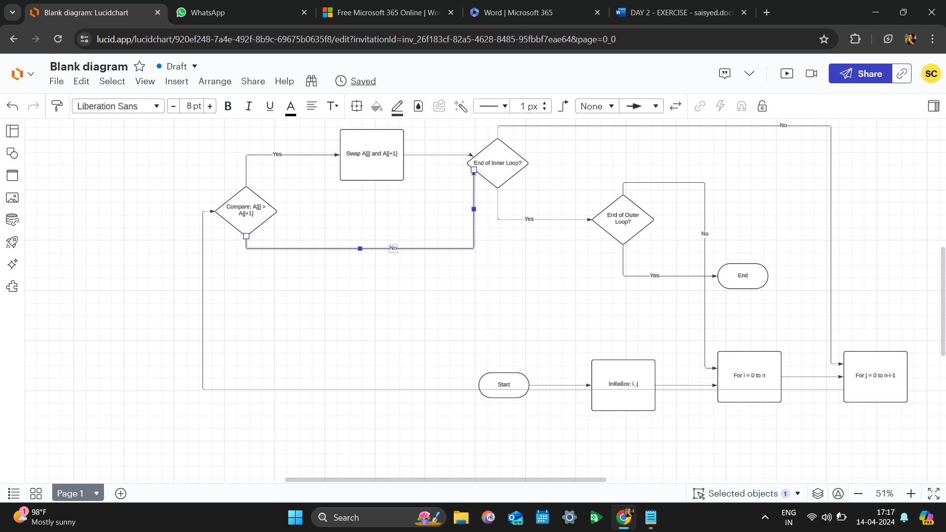

**Pseudocode:**

**start**

**accept array values from user**

**set int temp = 0**

**set n = array.length**

**for i range from 0 to n-1**

**for j range from 0 to n-i -1**

**if (array[j] > array[j+1])**

**temp = array[j]**

**array[j] = array[j+1]**

**array [j+1] = temp**

**end lopp**

**end**

ASSISGNMENT 2:-

start

accept the nth value number from user

call fibanoci(n) ---> fibanoci(int n)

print result if (n ==0 \\ n==1)

return 1

else

return fibanoci(n-1) + fibanoci(n-2)

big o nation is used to analysis time and space complexcity.

big o nation for this recursive fibanoci series is O(n^2)

pro :-

1.it is easy to code because code is diveded into smaller parts

cons :-

1.recursion can be slow

2. uses more memory at run time